January 2021membership drive GIVEAWAY

ENTER TO WIN A MULE DEER HUNT
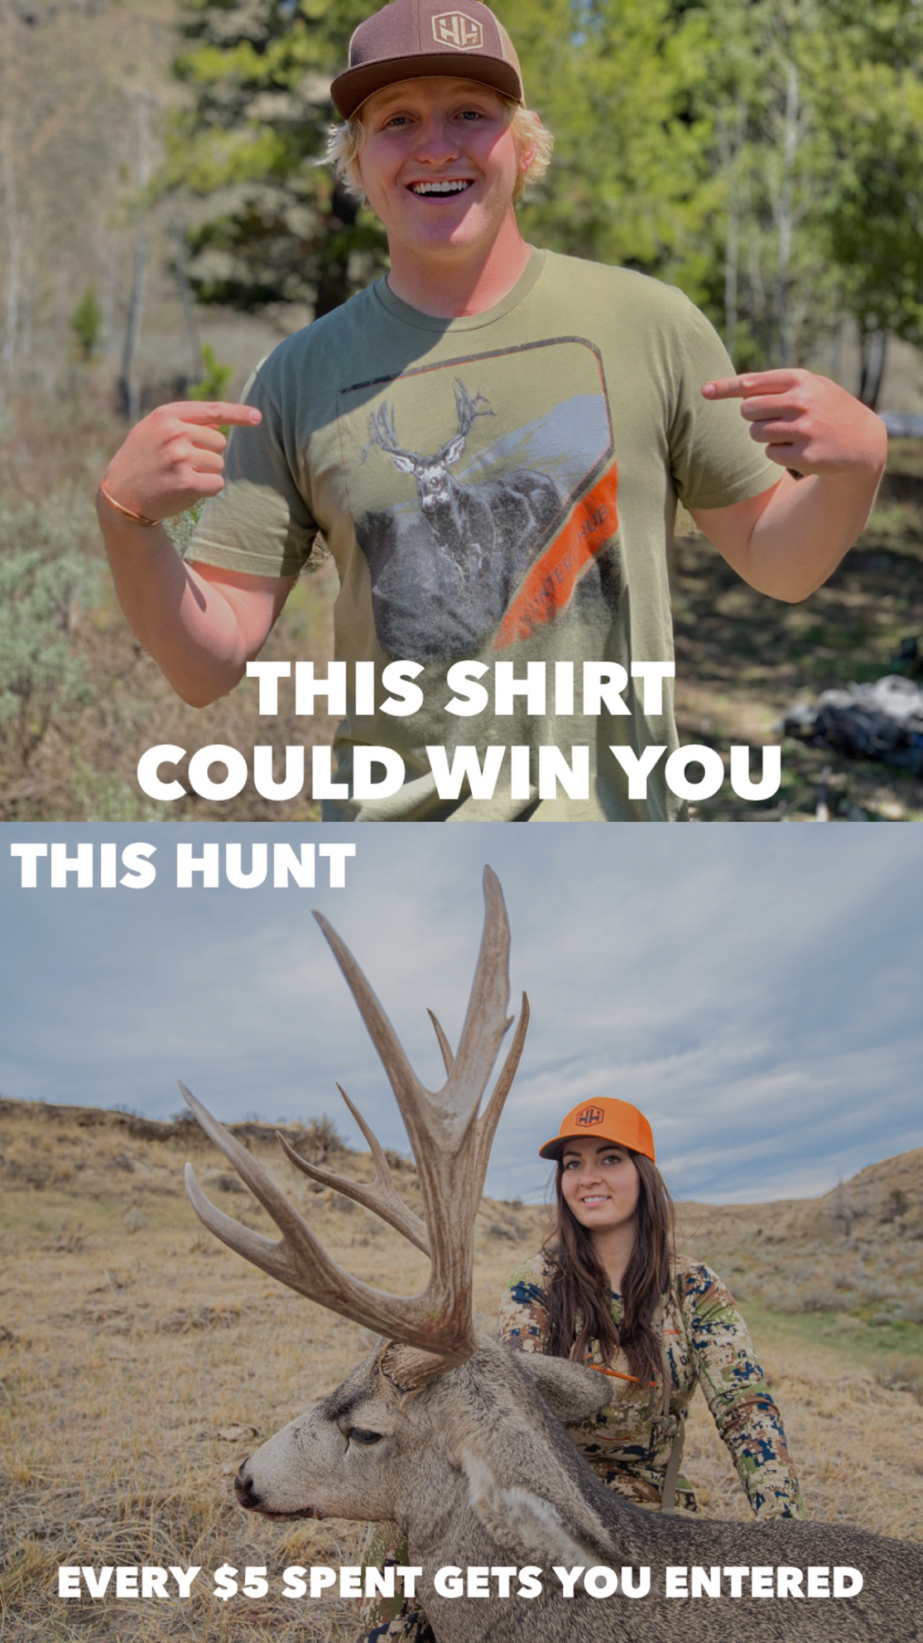

DESCRIPTION: Prize. One lucky customer will win a mule deer hunt with four horse outfitters, a Hunterz hub membership, and a FREE shoulder mount from Animal Artistry
] (approximate retail value (the "ARV"): [$6,500]) (the "Prize").

*Not included
is transportation to and from the hunt In Wyoming . Gun, Licenses, hunt insurance . Gratuities for staff and guide (recommend 10-15% of the cost of the hunt). Processing ,Dipping, Packing & shipping of trophies.

HOW TO ENTER
Entry will be based upon the date received (in the case of electronic entry) or postmarked date/received by (in case of mail-in entry).
A Sweepstakes Entry (“Ticket”) can be obtained by any one of the following methods subject to:
(a) the individual limitations for each entry method and
(b) an overall maximum of 5 per day, regardless of method of entry:
Automatic Entry: A member of Hunterz Hub Membership as of November 30, 2020 (a “Member”) will be awarded (1) automatic entries (“Automatic Member Entry”) per Promotion; Automatic Member Entry is limited to a one-time accumulation of (1) Automatic Member Entries. Automatic entry in any form will not increase your chances of winning.
Promotional Entry (when applicable): During the Promotion Period, Sponsor may issue Promotional Entry(s) by any method made available during the Promotion Period including, but not limited to, direct mail, email, mobile, magazine or in-store advertisement, for Ticket(s).
Free Method Entry: : By sending in a (“Mail-in Entry”) with a handwritten 3” X 5” card, in red ink. You must also include a color copy of your hunter education card to prove you can legally hunt. Entrant must also include one harvest photo of the entrant and a big game animal from any previous big game hunt. The photo must clearly show the face of the entrant. (By sending this photo you agree to let us use it for promotional purposes.) The photo should be a high-quality color digital image. The 3×5 card must include your Full Name, Hunter Education # with the phone number of the issuing state for verification, Address (must be the legal residential address in that state), City, State, Zip Code, Phone Number, Date of Birth, Gender, Email Address, indicate which hunt the entry is for and mailing it in a first-class stamped envelope to: Hunterz Hub, LLC., ATTN: Hunterz Hub, PO Box1697 Evanston, Wyoming 82931. No more than one (1) entry per envelope and each envelope shall be individually postmarked. Sponsor is not responsible for any incomplete, lost, late, illegible, mutilated, or misdirected entries. Sponsor reserves the right, in its sole discretion, to void any and all entries of an entrant who Sponsor believes has attempted to tamper with or impair the administration, fairness, security, or proper play of this sweepstakes, or to cancel the sweepstakes. All entries become the exclusive property of Sponsor and will not be returned or acknowledged
Hunterz Hub, LLC
Attn: Membership Drive Giveaway
p.o.box 1697
Evanston, Wy 82931

Hunterz Hub Giveaway

OFFICIAL RULES

No Purchase Necessary To Enter or Win.
A purchase will not increase your chances of winning.
Void where prohibited. U.S. Law Governs.

Description. The [Hunterz Hub Giveaway] (the "Promotion") begins on [ 1/1/2021] at 12:00 AM and ends on [2/28/2021 ] at 11:59 PM Mountain Standard Time (the "Promotional Period"). The Promotion is sponsored, administered, and fulfilled by Hunterz Hub, a [Wyoming corporation with its principal place of business at [insert address]] ("Hunterz Hub").

Eligibility. The Promotion is open to individuals who are: (i) legal residents of any of the fifty United States or Washington D.C. (excluding New York and Florida) or Canada (excluding Quebec) (the "Territory"); (ii) at least eighteen years of age, except where prohibited by law; and (iii) physically located within the Territory at the time of entry. Any individual who has, within the last twelve months, been employed by or performed services for Hunterz Hub or [insert Advertising Client] is not eligible to win. Household members or immediate family members of such individuals are also not eligible to win. Entry is void where otherwise prohibited or restricted by applicable law.

[How to Enter. There are two ways to enter:

- [Members Entry]. During the Promotional Period [a customer will receive 1 entry for every $5 spent on our online store ]

Free Method of Entry. : By sending in a (“Mail-in Entry”) with a handwritten 3” X 5” card, in red ink. You must also include a color copy of your hunter education card to prove you can legally hunt. Entrant must also include one harvest photo of the entrant and a big game animal from any previous big game hunt. The photo must clearly show the face of the entrant. (By sending this photo you agree to let us use it for promotional purposes.) The photo should be a high-quality color digital image. The 3×5 card must include your Full Name, Hunter Education # with the phone number of the issuing state for verification, Address (must be the legal residential address in that state), City, State, Zip Code, Phone Number, Date of Birth, Gender, Email Address, indicate which hunt the entry is for and mailing it in a first-class stamped envelope to:Hunterz Hub, LLC., ATTN: Hunterz Hub, PO Box1697 Evanston, Wyoming 82931. No more than one (1) entry per envelope and each envelope shall be individually postmarked. Sponsor is not responsible for any incomplete, lost, late, illegible, mutilated, or misdirected entries. Sponsor reserves the right, in its sole discretion, to void any and all entries of an entrant who Sponsor believes has attempted to tamper with or impair the administration, fairness, security, or proper play of this sweepstakes, or to cancel the sweepstakes. All entries become the exclusive property of Sponsor and will not be returned or acknowledged
Hunterz Hub, LLC
Attn: Membership Drive Giveaway
p.o.box 1697
Evanston, Wy 82931

Limit: [5] entries per person regardless of method or combination of methods of entry. All entries and submissions become the property of Hunterz Hub and will not be acknowledged or returned. Entries that are incomplete, incorrect, or that otherwise do not comply with these Official Rules will be void. In the event of a dispute as to the identity of an entrant, Hunterz Hub will consider the person who owns the email address associated with the entry to be the applicable entrant.]

Prize. One lucky customer will win a mule deer hunt with Four Horse Outfitters, a Hunterz hub membership, and a FREE shoulder mount from Animal Artistry
] (approximate retail value (the "ARV"): [$6,500]) (the "Prize").

The Winner shall not assign or transfer the Prize to another person. The Prize may not be exchanged for any other item or redeemed for cash. If the Prize cannot be awarded due to circumstances beyond the control of Hunterz Hub, a substitute prize of equal or greater value may be awarded. If the Winner cannot accept the Prize or any portion thereof, the Prize may be forfeited at the sole discretion of Hunterz Hub. The ARV represents Hunterz Hub's good faith determination as to its maximum retail value and is subject to price fluctuations based on, among other factors, the gap in time between the time at which the ARV is estimated and the time at which the Prize is awarded. The Winner is solely responsible for all federal, state, local, or other taxes and any costs or expenses relating to the use, acceptance, or possession of the Prize, except as specifically provided for within the Official Rules. The Winner will receive an IRS 1099 form if the Prize has an ARV of $600 or greater.

THE PRIZE IS AWARDED "AS-IS" AND WITHOUT WARRANTY OF ANY KIND, WHETHER EXPRESS OR IMPLIED, INCLUDING WITHOUT LIMITATION ANY IMPLIED WARRANTY OF MERCHANTABILITY OR FITNESS FOR A PARTICULAR PURPOSE. HUNTERZ HUB (AND EACH OF ITS EMPLOYEES, AGENTS, AND REPRESENTATIVES) EXPRESSLY DISCLAIMS ANY AND ALL RESPONSIBILITY AND LIABILITY ARISING FROM USE OR REDEMPTION OF THE PRIZE, INCLUDING BUT NOT LIMITED TO ANY DAMAGES OR INJURIES SUSTAINED BY THE WINNER FOR ANY REASON, INCLUDING FROM ANY PART OF THE PRIZE OR ANY OTHER CAUSES BEYOND HUNTERZ HUB'S REASONABLE CONTROL.

Odds of Winning. The odds of winning depend on the number of eligible entries. Each entry has an equal chance to win regardless of number of entries.

Winner Selection and Notification. On or about the close of the Promotional Period, Hunterz Hub shall select the Winner(s) of the Promotion via a random drawing from all eligible entries received during the Promotional Period. The Winner(s) of the Promotion shall be contacted within approximately five days of the drawing date by telephone, mail, or email, in Hunterz Hub's sole discretion and with reference to the contact information within such Winner's membership account or mail-in entry. The Winner must respond within thirty days after Hunterz Hub provides such notice. Winner may additionally be required to verify his or her address and return any affidavits, liability releases, or other documents covering eligibility, liability, or publicity as may be reasonably requested by Hunterz Hub. Failure to comply with the foregoing, or any other term or provision of these Official Rules, may result in forfeiture of the Prize, at Hunterz Hub's sole discretion. If Hunterz Hub determines that the Winner has forfeited the Prize, Hunterz Hub will not select an alternative winner.

Conditions of Participation and Release. The Promotion is void where prohibited or restricted by law. All federal, state, and local laws and regulations apply. By participating in the Promotion, entrants agree (and agree to confirm same in writing if reasonably requested by Hunterz Hub): (i) to release, defend, indemnify, and hold harmless Hunterz Hub (and its employees, agents, and representatives) from and against any liability, loss, claim, or cause of action arising out of participation in the Promotion or in connection with the acceptance, possession, or use of the Prize; and (ii) to waive all rights to punitive, indirect, incidental, or consequential damages, attorneys' fees, court costs, or any damages multipliers, except where such waivers are prohibited by law, in connection with any claim against Hunterz Hub arising under these Official Rules or the Promotion. The Winner authorizes Hunterz Hub to use his or her name, likeness, biographical data, and city or state of residence in programming or promotional material or on a winners list without further compensation, except where prohibited by law, and without territorial or time limitations. Hunterz Hub may use the aforementioned materials at its sole discretion without further obligation or compensation, except as prohibited by law. Hunterz Hub shall additionally not be liable for: (i) technical or software malfunctions, lost connections, or other transmission errors; (ii) data corruption, theft, destruction, or unauthorized access to or alteration of Promotion-related materials; (iii) administrative or technological errors associated with the Promotion; (iv) lost, late, misdirected, damaged, illegible, or incomplete entries; or (v) the failure of any third party to comply with instructions provided by Hunterz Hub in connection with the Promotion or the Prize. By participating, each entrant agrees to be bound by these Official Rules and acknowledges that Hunterz Hub's decisions hereunder shall be final and binding.

Modification or Termination. If, for any reason, the Promotion cannot be executed as planned, including but not limited to by reason of technological infection by virus or bug, tampering, unauthorized intervention, fraud, technical failure, social media mandate, or any other cause beyond the control of Hunterz Hub that corrupts or affects the security, administration, integrity, fairness, or proper conduct of the Promotion, or if the Promotion is compromised or becomes corrupted in any way, electronically or otherwise, Hunterz Hub reserves the right, in its sole discretion, to void suspect entries and/or modify, suspend, or terminate the Promotion. If the Promotion is terminated before the close of the Promotional Period, Hunterz Hub may, in its sole discretion, select the Winner in a random drawing from among the eligible, nonsuspect entries received as of the time of termination.

Disqualification. Hunterz Hub reserves the right, in its sole discretion, to disqualify any individual who tampers with or attempts to tamper with the Promotion in any way, acts in a disruptive or unfair manner, attempts to enter the Promotion using any automatic or programmed method or service, or who otherwise fails to abide by these Official Rules.

Privacy. Any personal information supplied to Hunterz Hub in connection with the Promotion will be subject to Hunterz Hub's [Membership & Privacy Policy], available at: [URL], which may be modified from time to time.

Prize Winner List. To obtain a copy of these Official Rules, visit: [URL]. Results of the Promotion will be posted on the Hunterz Hub website and across its social media channels. You may also submit a request for information on past winners by sending an email to us at: [insert email].

Law and Jurisdiction. The Promotion is offered only in the Territory and is governed by the laws of the State of Wyoming, without regard to its conflict-of-laws provisions. Any and all disputes, claims, and causes of action arising under or in connection with the Promotion shall be resolved individually and without resort to any form of class action. By participating in the Promotion, entrants irrevocably consent to the sole and exclusive jurisdiction of the state or federal courts sitting in the State of Wyoming, County of Uinta, for any action arising under or in connection with the Promotion.

14640082

